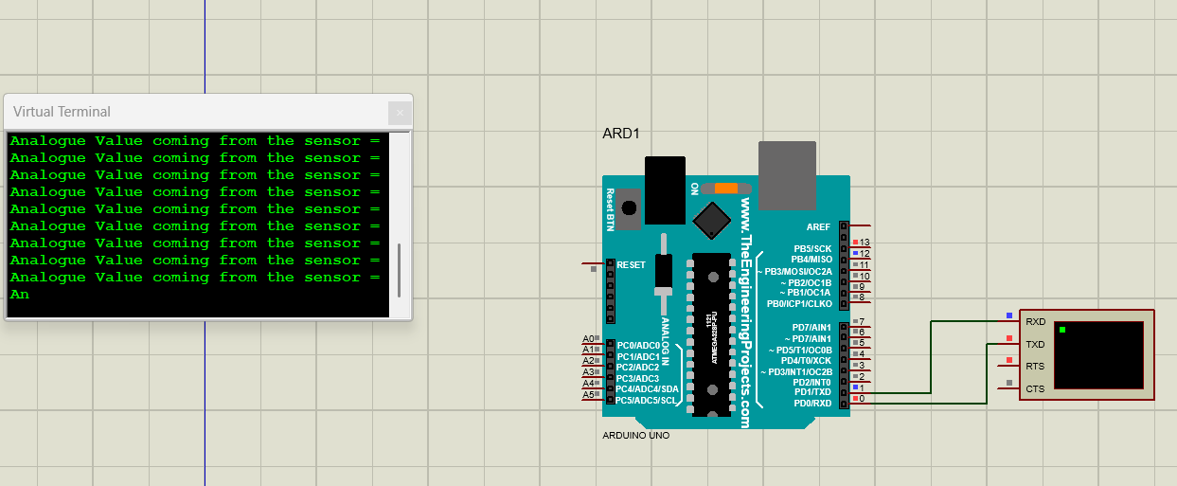
Experiment 7:

Source code:
#define GreenLed 13
#define Sensor A0
void setup()
{
pinMode(13, OUTPUT);
pinMode(12, OUTPUT);
pinMode(A0, INPUT);
Serial.begin(9600);
}
void loop()
{
int value = analogRead(A0);
Serial.print("Analogue Value coming from the sensor = ");
Serial.println(value);
delay(100);
if(value < 600)
{
digitalWrite(13, HIGH);
}
else
{
digitalWrite(13, LOW);
}
delay(20);
}

